

A Project Report

On

**“PSCS235-A One Stop Solution focusing on Tourism”**

Batch Details

|  |  |  |
| --- | --- | --- |
| Sl. No. | Roll Number | Student Name |
| 1 | 20211CSE0846 | VAISHNAVI C |
| 2 | 20211CSE0298 | SHRUTHI V |
| 3 | 20211CSE0308 | RUTHIKA S SHETTY |

**School of Computer Science,**

**Presidency University, Bengaluru.**

Under the guidance of,

**Ms. Sreelatha P.K**

**Associate Professor**

School of Computer Science,

Presidency University, Bengaluru

**CONTENTS**

1. Introduction about Project
2. Literature Review
3. Objectives

## Methodology

1. Timeline for Execution of Project
2. Expected Outcomes
3. Conclusion
4. References

**INTRODUCTION**

This project aims to create an innovative data mining solution capable of accurately forecasting tourists' travel preferences, specifically for optimizing the scheduling of domestic tour packages.

The project has three main objectives:

1. To build a clustering model that efficiently groups the collected data into distinct clusters for classification purposes.
2. To develop data mining models using predictive techniques that can forecast tourist travel clusters, enabling more effective planning of domestic tour packages.
3. To provide well-founded and actionable recommendations to the appropriate authorities.

**LITERATURE REVIEW**

**1. Paper Title**: *Smart Tourism Route Planning System Based on Machine Learning Algorithm*  
**Authors**: Zhenzhen Yu, Shan Wang  
**Summary**: Focuses on developing an efficient tourism route planning system using machine learning techniques. It optimizes routes based on various user preferences and constraints.  
**Advantages**: Efficient route planning and customization based on user preferences.  
**Limitations**: May require large datasets for accurate predictions.

**2. Paper Title**: *A Study on Sustainable Tourism and Application of Sentiment Analysis in the Tourism Industry*  
**Authors**: Chandra Prakash Gupta, V. V. Ravi Kumar  
**Summary**: Explores the application of sentiment analysis to gauge tourists' opinions and emotions towards sustainable tourism practices, helping improve tourism management strategies.  
**Advantages**: Promotes sustainable tourism practices using real-time feedback.  
**Limitations**: Sentiment analysis may face challenges in accurately interpreting emotions due to language nuances.

**3.Paper Title**: *Sentiment Analysis on Tourism Place using Naive Bayes*  
**Authors**: Aldy Rialdy Atmadja et al.  
**Summary**: Uses the Naive Bayes algorithm to perform sentiment analysis on tourists' reviews of various tourism locations, providing insights into public perception.  
**Advantages**: Simple and efficient sentiment classification model.  
**Limitations**: Naive Bayes has limitations in handling complex language structures and ambiguous sentiments.

**4.** **Paper Title**: *Tourist Movement Analysis Using Social Media Data*  
**Authors**: Andry Alamsyah et al.  
**Summary**: Analyzes tourist movement patterns through social media data to understand their behaviors, preferences, and frequently visited places.  
**Advantages**: Utilizes real-time social media data for accurate tourist movement tracking.  
**Limitations**: Social media data can be biased or incomplete, limiting accuracy.

**5. Paper Title**: *The Impact of Artificial Intelligence on Tourism Sustainability: A Systematic Mapping Review*  
**Authors**: Fisnik Dalipi et al.  
**Summary**: Reviews the applications of AI in promoting tourism sustainability, including resource management, tourist behavior prediction, and eco-friendly practices.

**Advantages**: Highlights the potential of AI in promoting eco-friendly tourism practices.  
**Limitations**: Systematic reviews may lack experimental validation of concept

**6. Paper Title**: *Tourist Behavior Analysis Based on Digital Pattern of Life*  
**Authors**: Sergei Mikhailov et al.  
**Summary**: Investigates tourists' behavior through digital patterns of life, analyzing factors like location history, online interactions, and preferences to predict behavior.  
**Advantages**: Provides personalized insights based on digital footprints.  
**Limitations**: Data privacy concerns may arise due to tracking digital patterns.

**7. Paper Title**: *A Personalized Hybrid Tourism Recommender System*  
**Authors**: Mohamed Elyes Ben Haj Kbaier et al.  
**Summary**: Proposes a hybrid recommendation system combining collaborative filtering and content-based filtering to provide personalized tourism recommendations

**8.** **Paper Title**: *Prediction of Tourist Behavior: Tourist Visiting Places by Adapting Convolutional Long Short-Term Deep Learning*  
**Authors**: Jaruwan Kanjanasupawan et al.  
**Summary**: Utilizes a deep learning model to predict tourist behavior and visiting patterns by processing historical tourism data.  
**Advantages**: High accuracy in predicting tourist behavior using advanced deep learning techniques.  
**Limitations**: Requires significant computational resources and large datasets.

**9.** **Paper Title**: *Research on Smart Tourism System Based on Artificial Intelligence*  
**Authors**: Mengdan Xu  
**Summary**: Explores the use of AI in smart tourism systems to enhance tourist experiences through intelligent data analysis and decision-making.  
**Advantages**: Enhances tourist satisfaction and optimizes tourism services using AI.  
**Limitations**: Implementation requires advanced technical infrastructure and expertise.

**10. Paper Title**: *Tourism Recommendation System Based on Knowledge Graph Feature Learning* **Authors**: Fengsheng Zeng, Yan’e Zheng  
**Summary**: Develops a tourism recommendation system using knowledge graph-based feature learning to improve the accuracy and relevance of recommendations.  
**Advantages**: Knowledge graphs provide rich and interconnected data for precise recommendations.  
**Limitations**: Complex model structure can be difficult to implement and maintain

**OBJECTIVES**

Objective 1:

**Develop a robust clustering algorithm for tourist data segmentation**

* Explore and implement various clustering algorithms (e.g., K-means, hierarchical clustering, DBSCAN) to effectively segment tourist data based on relevant attributes (e.g., demographics, preferences, behaviors).

Objective 2:

**Construct predictive models for forecasting tourist travel clusters**

* Develop and evaluate predictive models (e.g., time series analysis, regression models, classification models) to forecast the evolution of tourist clusters over time.

Objective 3:

**Analyze and interpret the results of clustering and predictive models**

* Conduct an in-depth analysis of the clusters identified and the predictions generated by the models, identifying key characteristics and trends.

Objective 4:

**Develop actionable recommendations for tourism authorities**

* Based on the clustering and predictive results, provide specific and actionable recommendations to tourism authorities, such as optimizing resource allocation, developing targeted marketing campaigns, and improving service offerings.

**EXPERIMENTAL DETAILS/METHDOLOGY**

Software used:

* Python 3.x
* Jupyter Notebook / Google Colab
* Pandas, NumPy (Data processing)
* Matplotlib, Seaborn, Plotly (Visualization)
* Scikit-learn, TensorFlow, PyTorch (Machine Learning)
* XGBoost / LightGBM (Advanced models)
* BeautifulSoup / Scrapy (Web scraping)
* APIs (Google Maps, OpenWeather, etc.)

**METHODOLOGY**

1. Data Collection: Gather data from social media, travel platforms, and user interactions.
2. Data Pre-processing: Clean, normalize, and extract relevant features.
3. NLP: Analyse text for sentiment, topics, and entities.
4. Machine Learning: Build models for recommendation, prediction, and clustering.
5. Knowledge Graph: Construct a graph representation of the tourism domain.
6. Visualization: Create interactive dashboards for insights.

**OUTCOMES**

**1. Accurate Tourist Segmentation:** ​

* The clustering model is expected to segment tourists based on demographics, preferences, and behaviors effectively. This will allow tourism authorities and companies to better understand different tourist groups and cater to their needs. ​

**2. Improved Forecasting of Tourist Travel Patterns:** ​

* Predictive models developed will help forecast future tourist behaviors and travel preferences, enabling tourism operators to plan more efficiently and anticipate the needs of tourists in real-time.

**3. Optimized Tour Package Scheduling:** ​

* By forecasting tourist travel clusters, the project aims to optimize the scheduling and customization of domestic tour packages, increasing efficiency in resource allocation and improving tourist satisfaction. ​

**4. Actionable Insights for Tourism Authorities:** ​

* The analysis of the clusters and predictions will provide tourism authorities with actionable insights, such as how to allocate resources, design targeted marketing campaigns, and improve service offerings. ​

**5. Contribution to Sustainable Tourism:** ​

* The project will contribute to sustainable tourism practices by optimizing travel routes and packages, reducing unnecessary travel, and promoting eco-friendly options aligned with sustainability goals.

**TIMELINE OF THE PROJECT/ PROJECT EXECUTION PLAN**

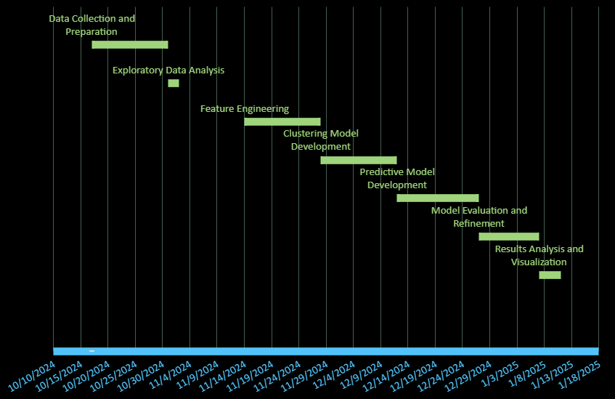

**CONCLUSION**

* This AIML project aims to enhance the tourism industry through advanced data analysis techniques. By building an efficient clustering model, we can categorize tourist data into distinct segments, improving understanding of traveler demographics and preferences.
* Additionally, our predictive models will forecast travel patterns, enabling better planning of domestic tour packages tailored to specific tourist needs. The actionable recommendations derived from our analyses will empower tourism authorities to make informed decisions, optimize resource allocation, and promote sustainable practices.
* Ultimately, this project seeks to create a more efficient and responsive tourism ecosystem, fostering growth and sustainability in the industry.

**REFERENCES**

* <https://ieeexplore.ieee.org/document/9701947>
* <https://ieeexplore.ieee.org/document/10131818>
* <https://ieeexplore.ieee.org/document/9263945>
* <https://ieeexplore.ieee.org/document/8308293>
* <https://ieeexplore.ieee.org/document/8823542>
* <https://ieeexplore.ieee.org/document/10165293>
* <https://ieeexplore.ieee.org/document/9076546>
* <https://ieeexplore.ieee.org/document/9695769>
* <https://ieeexplore.ieee.org/document/10072232>
* <https://ieeexplore.ieee.org/document/10704180>
* <https://ieeexplore.ieee.org/document/10366891>
* <https://www.data.gov.in/>